**Class Assessment-1**

Q.1 What is optimization ? Define the types of optimization.

Ans- Optimization is the process by which we modify and improve the efficiency and performance of computer programs and software systems. It involves identification and addressing the redundancies and inefficiencies to ensure organized and efficient working of the program.

Types of optimization are-

1. Time-Complexity Optimization:

* Algorithm selection:- Choosing efficient algorithm for a task.
* Data structure selection:- Selecting appropriate data structures that are ttime-effcient.

1. Space Complexity:

* Memory allocation(and deallocation):- To avoid bottlenecks and memory leaks, managing memory allocation and deallocation efficiently is important.
* Data compression:- Compressing data to reduce storage requirments.

1. Code readability:

* Commenting
* Formatting
* Modularization

1. Energy consumption optimization:

* Power-saving techniques
* Using cache

1. Performance profiling

* Identifying bottlenecks
* Prioritize optimization

Q.2 Minimize the function for the code f(x,y)=x^2+y^2+3x+4y+5.

Ans-

Source Code:-

import sympy as sp

x,y=sp.symbols('x y')

print("Given Function f(x,y) is:- f=x**2+y**2+3*x+4*y+5 ")

f=x**2+y**2+3*x+4*y+5

print("Derivative w.r.t x: ")

dfdx=sp.diff(f, x)

print(dfdx)

print("Derivative w.r.t y: ")

dfdy=sp.diff(f, y)

print(dfdy)

val = sp.solve([dfdx, dfdy], [x, y])

x_val = val[x].evalf()

y_val = val[y].evalf()

val1= [x_val, y_val]

print("Minimum found at (x,y):- ",val1)

min_f=f.subs({x: x_val,y: y_val})

print("Minimum value of the function is:-",min_f)

Output:-

Given Function f(x,y) is:- f=x**2+y**2+3*x+4*y+5

Derivative w.r.t x:

2*x + 3

Derivative w.r.t y:

2*y + 4

Minimum found at (x,y):- [-1.50000000000000, -2.00000000000000]

Minimum value of the function is:- -1.25000000000000

Code Snippet:-

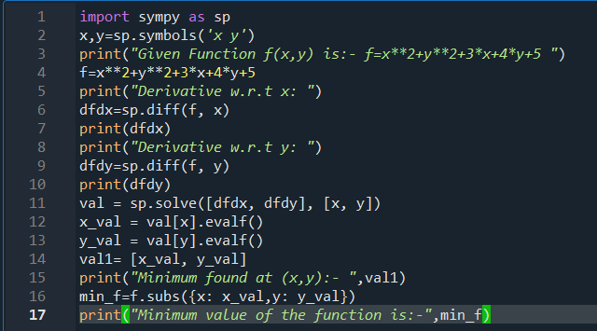

Output:-

